Assignment Submission Report
Name:Sergio Gonzalez
Course / Cohort: Project 114, Cohort 65
Assignment: 3
GitHub Repository Link:

Evidence of Functionality

Frontend/UI
Attach 3 screenshots only:
- Main screen
- One interaction working
- One validation / error state

Backend/Logic
- Screenshot of one key component/element (route / controller / service)

AI Disclosure (Required) – Highlight the one that applies
- I did not use AI
- I used AI for help
- AI generated parts of my code

cstack instance:
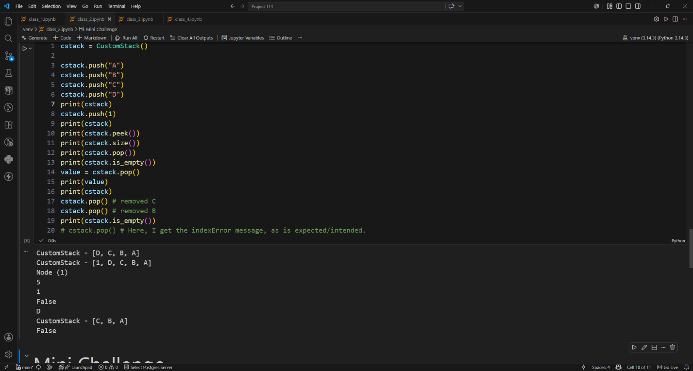

CustomStack Definition:
